KE24 -

Functionality
In this report you can display a specific amount of line items in the line item list. The line item list is especially useful for displaying characteristics that you do not use for creating profitability segments and that you have deactivated accordingly in Customizing. In costing-based Profitability Analysis, these characteristics are still filled in the line item and hence listed in the line item list.

Scenario
Report of all line items coming from billing documents for the whole year 2002 must be prepared.

Requirements
None.

Menu Path | SAP menu → Accounting → Controlling → Profitability Analysis → Information System → Display Line Item List → KE24 - Actual
Transaction Code | KE24

1. Double Click on KE24 - Actual

Display Actual Line Items: Initial Screen

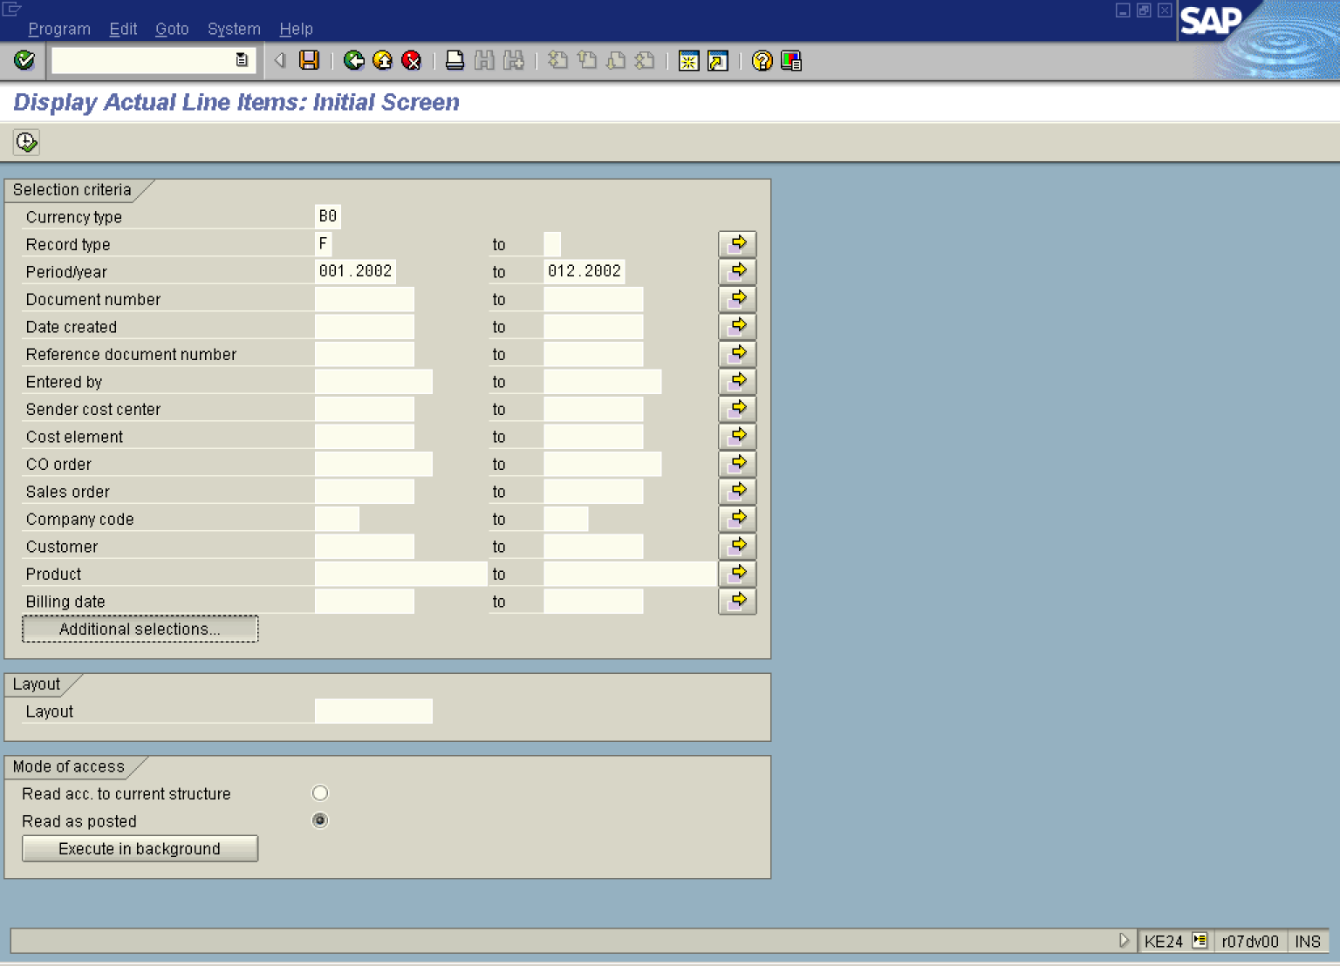

2. Update the following fields:

Field Name | Field Description | Values
Currency type | Code identifying the currency in CO-PA, i.e. ‘B0’ Operating Concern Currency | Example: B0
Record type | Record type, i.e. ‘F’ Billing document | Example: F
Period/year | Period/year, 0MM.YYYY | Example: 001.2002
to | To Period, 0MM.YYYY | Example: 012.2002

3. Click Layout .

Choose layout (1) 1 Entry found
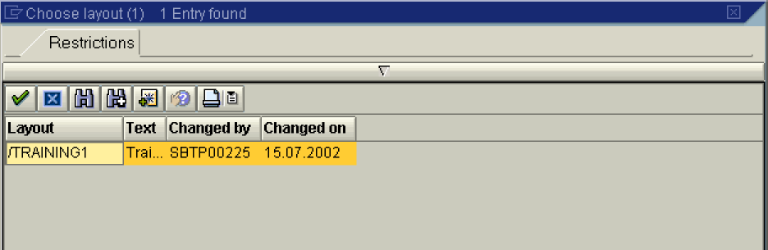

4. Select /TRAINING1 - Trai... - SBTP00225 - 15.07.2002 in list box.

Display Actual Line Items: Initial Screen

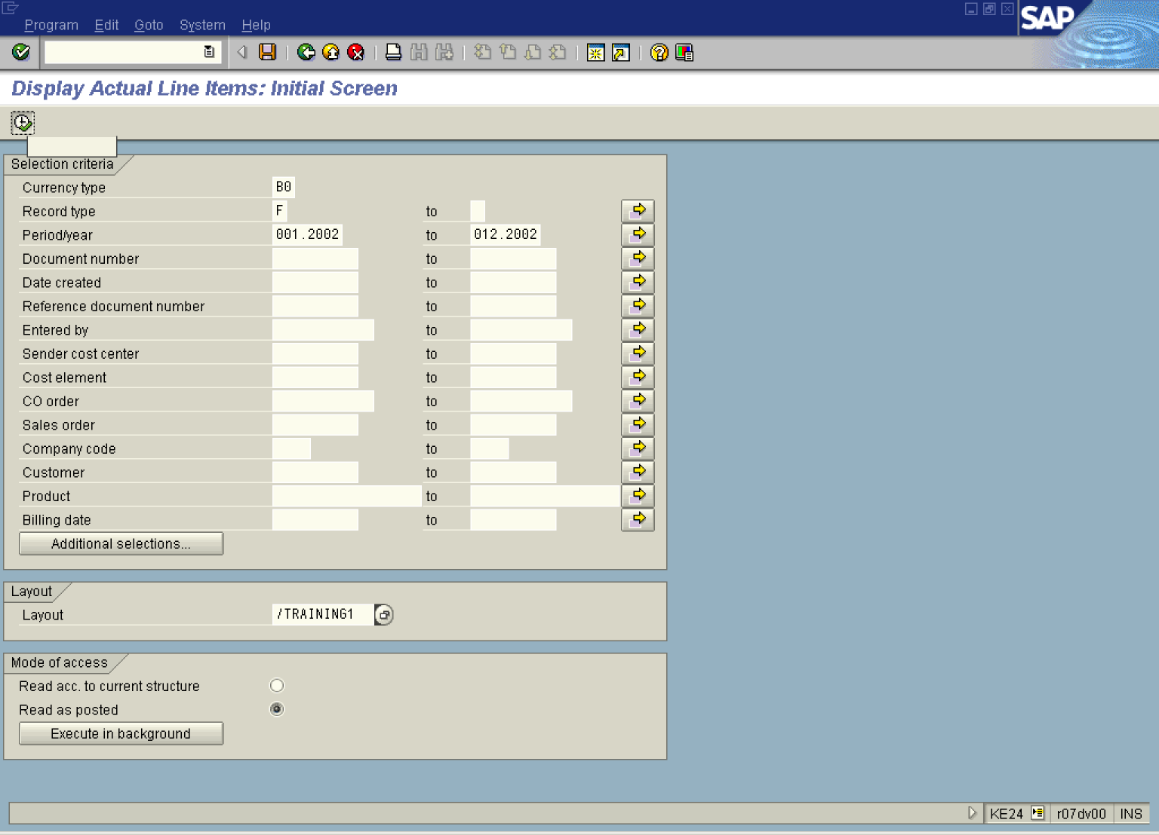

5. Click .

Display Actual Line Items: List

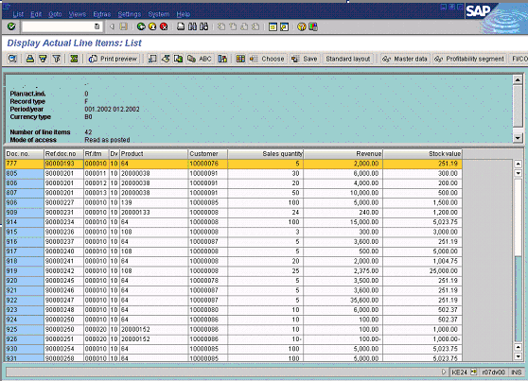

Display Line Items

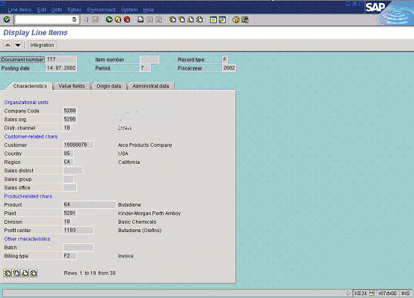

6. Click <tab button> Value fields .

Display Line Items

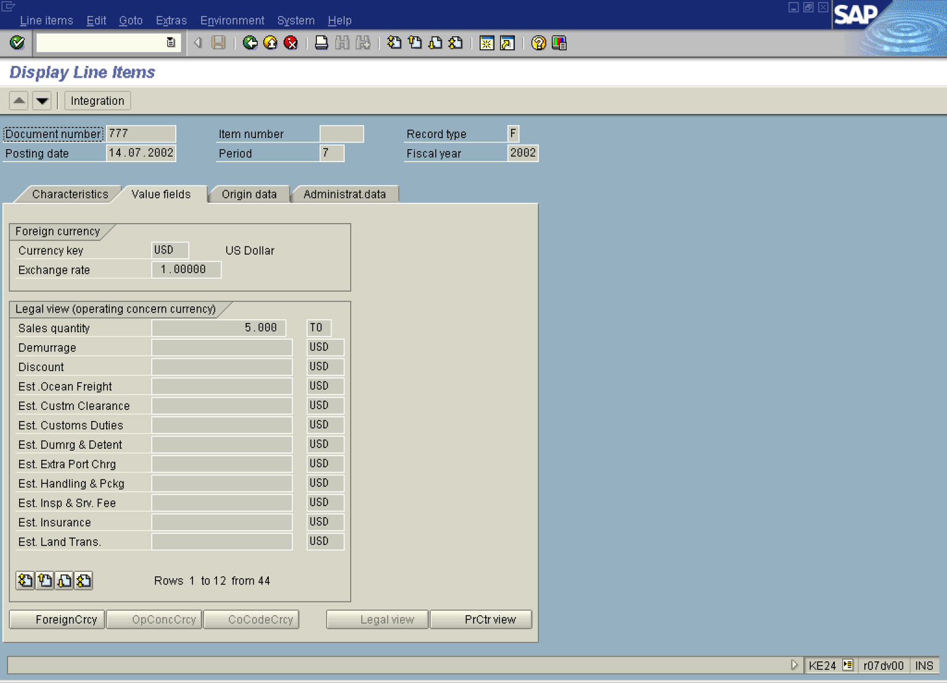

7. Click <tab button> Origin data .

Display Line Items

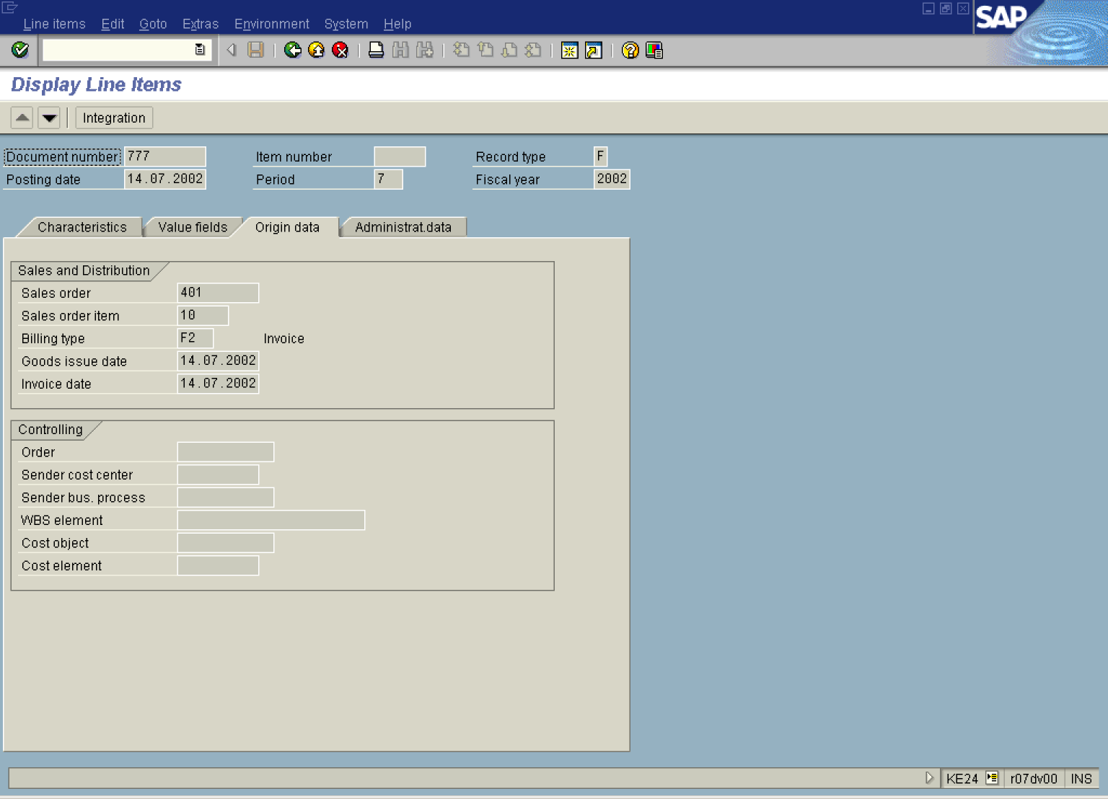

8. Click <tab button> Administrat.data .

Display Line Items

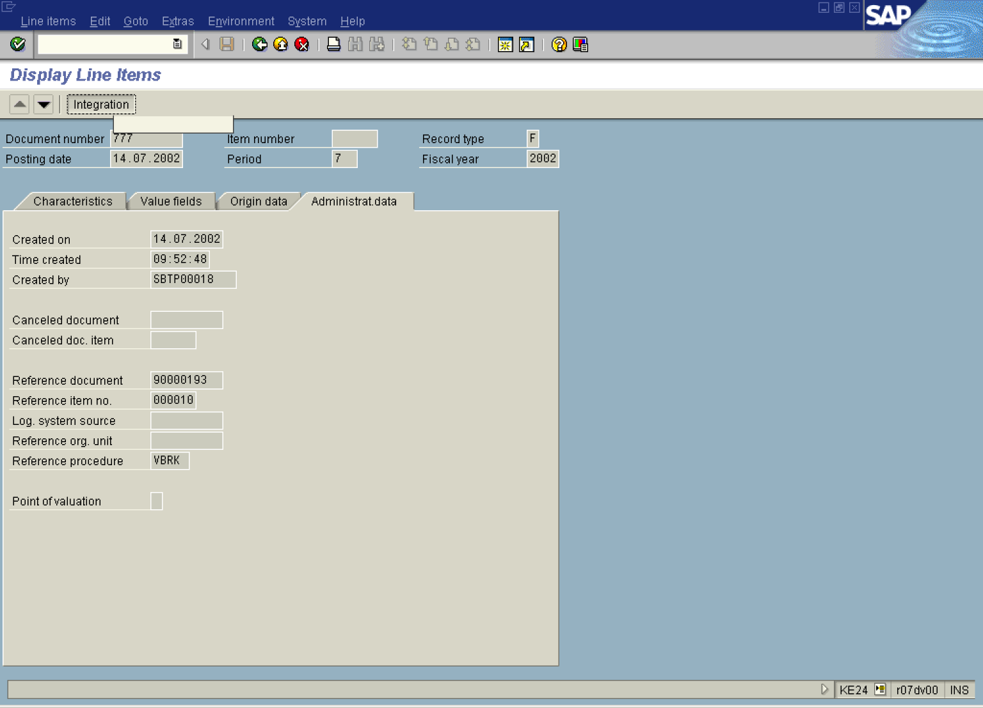

9. Click Integration Button .

Integration: Selection of Transactions

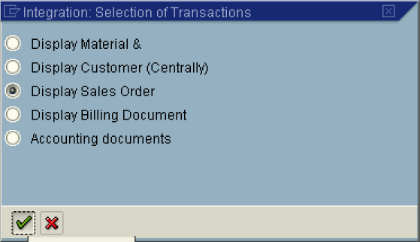

10. Click Display Sales Order .
11. Click Button .

Display Sales Order 401: Overview

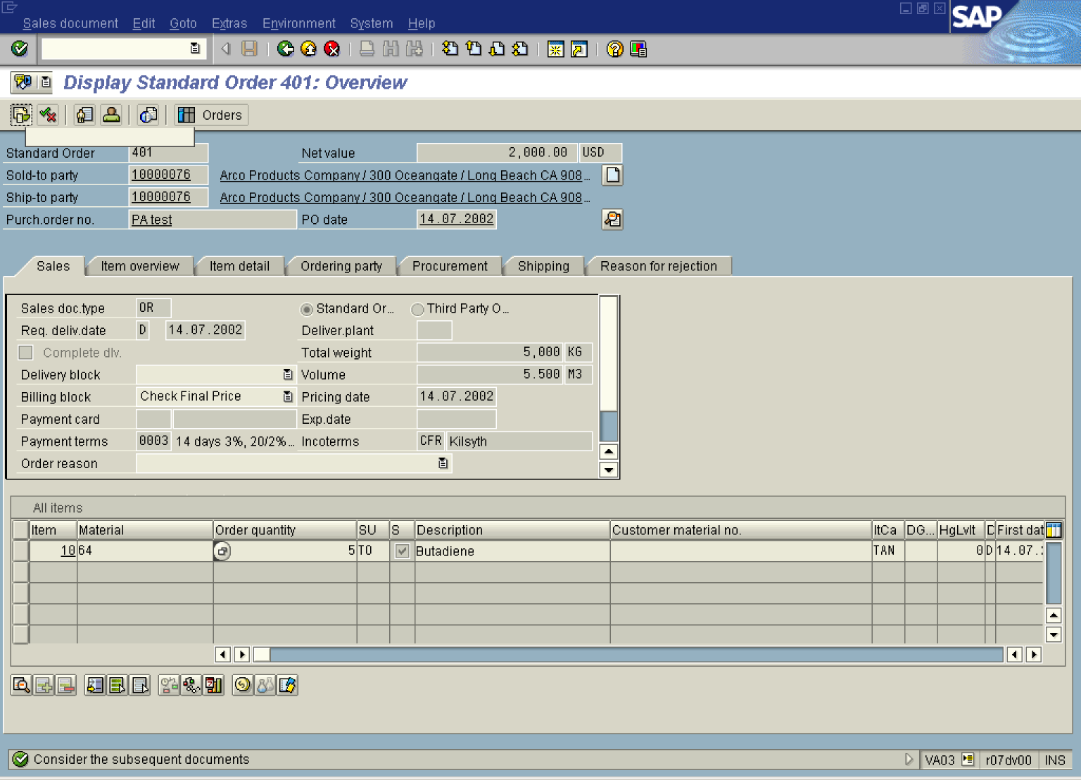

12. Click Button ‘Document flow’

Document Flow

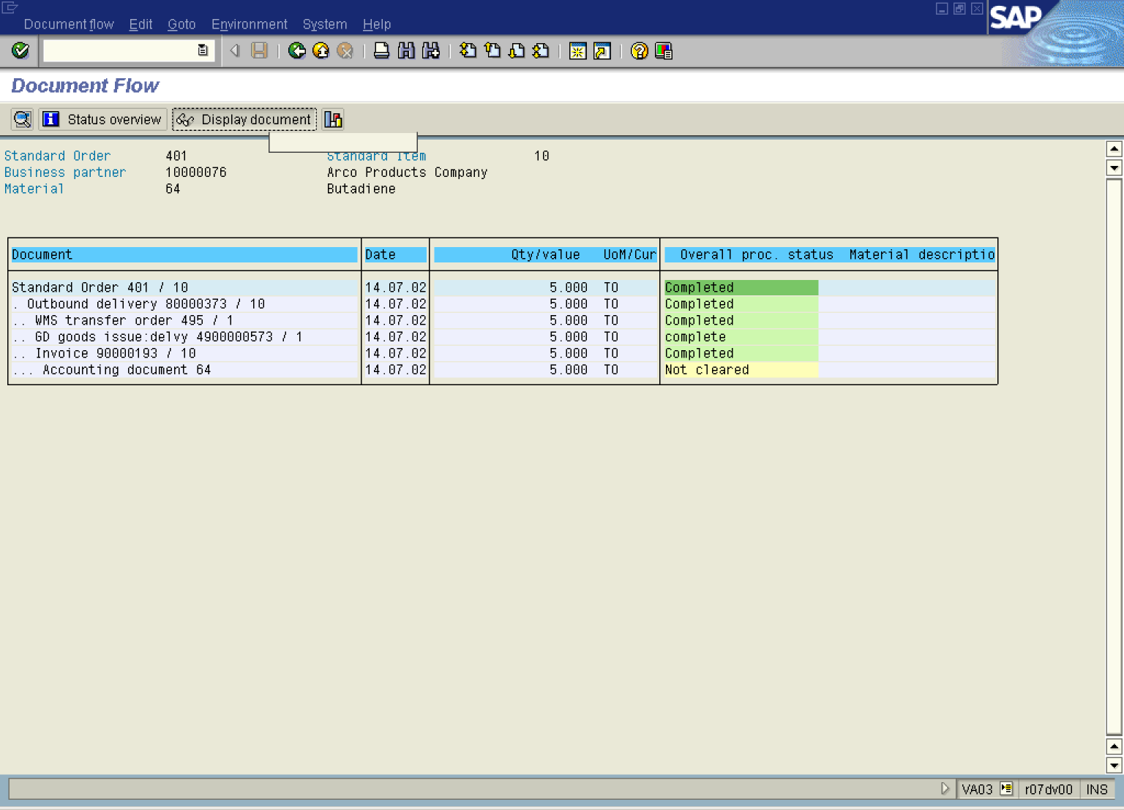

13. Click .. Invoice 90000193 / 10 Button .

14. Click Display document Button .

Invoice 90000193 (F2) Display: Overview of Billing Items

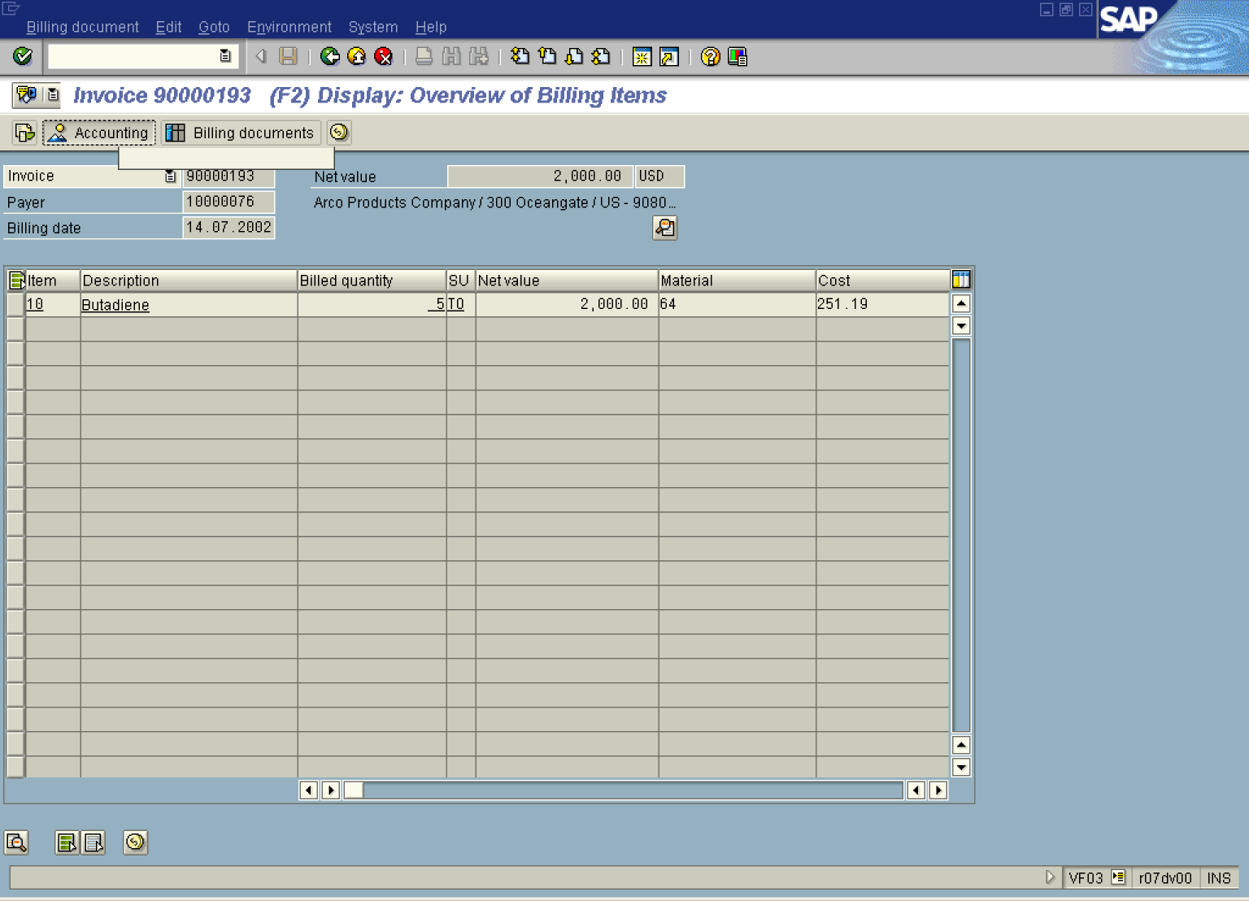

15. Click Accounting Button .

List of Documents in Accounting
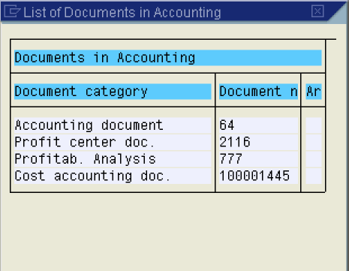

16. Click 777 Button .

Note: Now you are displaying the same CO-PA document '777' from side of a Billing Document. According to document flow you made a circle.

Display Line Items

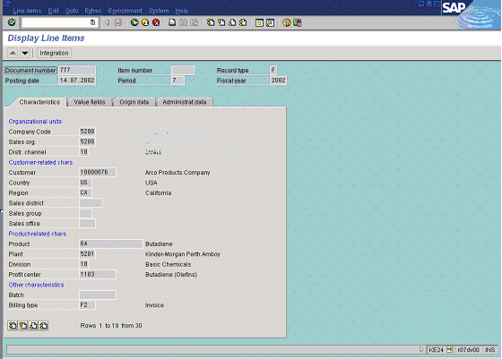

17. Click Back

List of Documents in Accounting

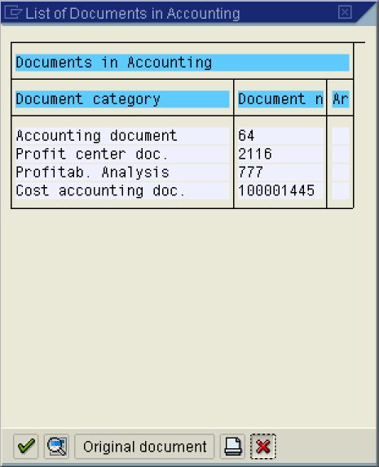

18. Click Cancel Button .

Invoice 90000193 (F2) Display: Overview of Billing Items

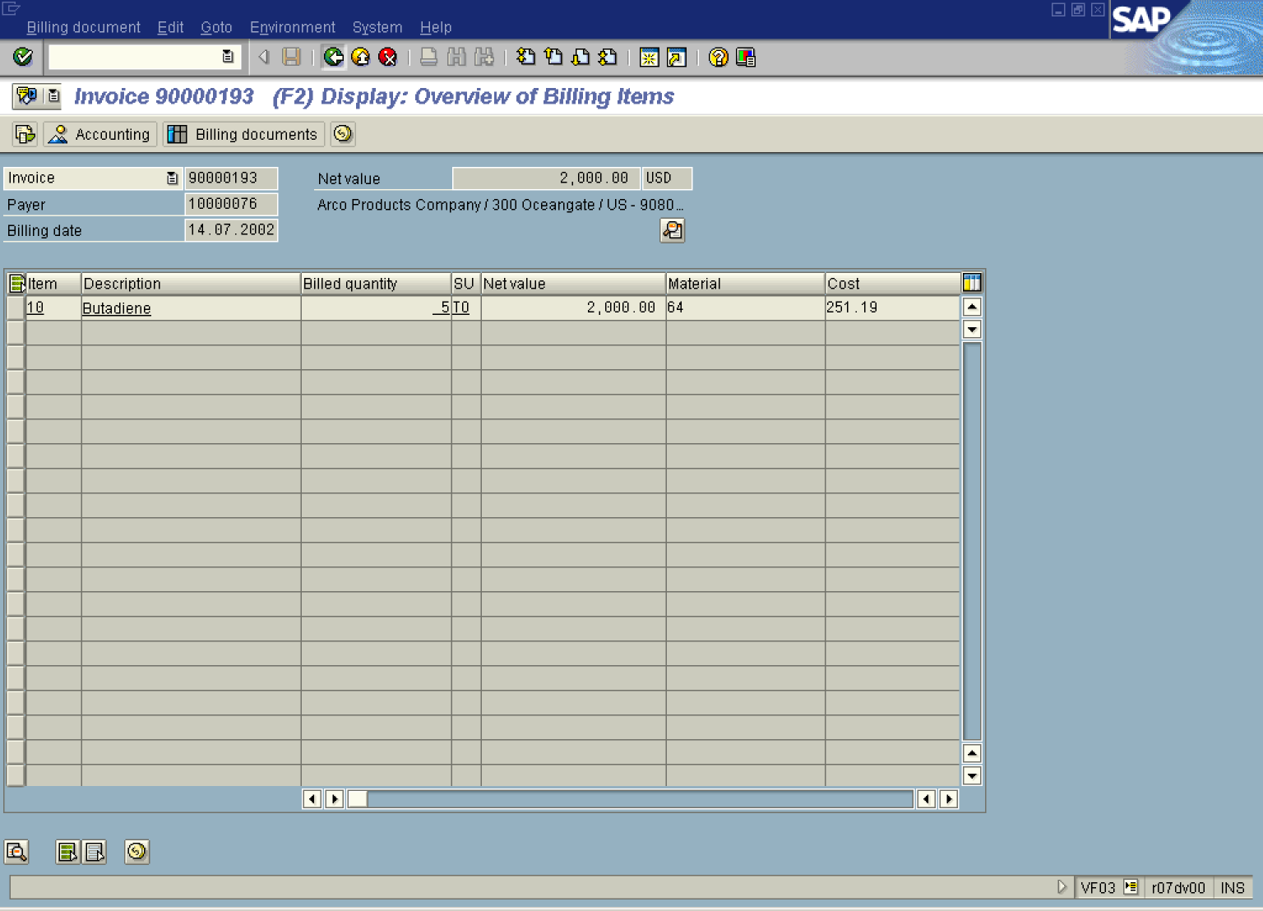
19. Click Back
Document Flow

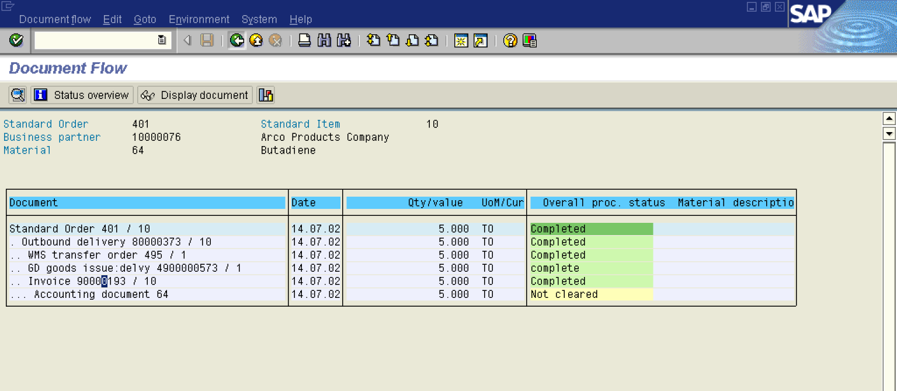

20. Click Back 

Display Sales Order 401: Overview
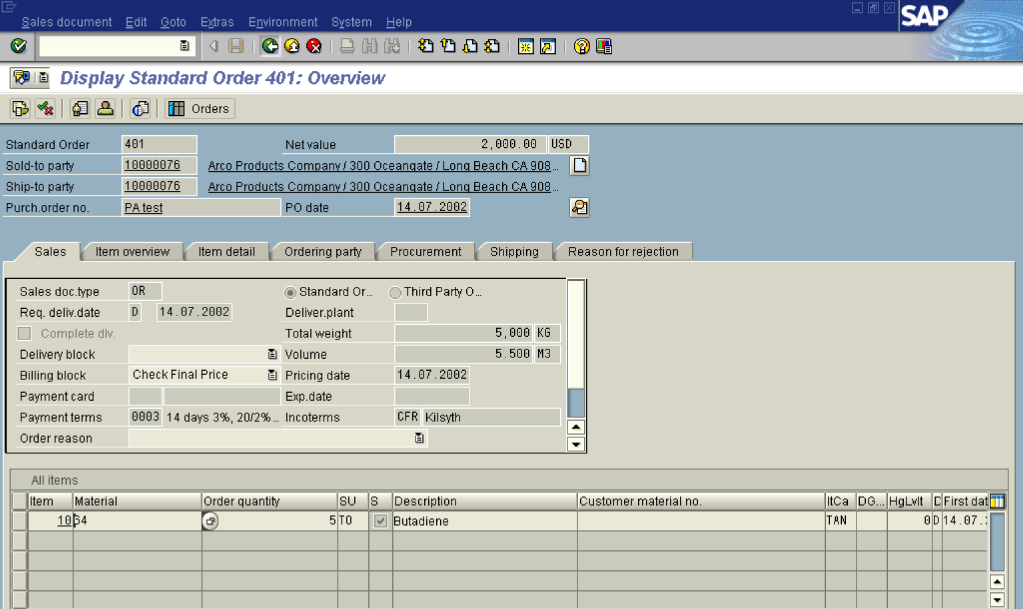

21. Click Back .

Display Line Items

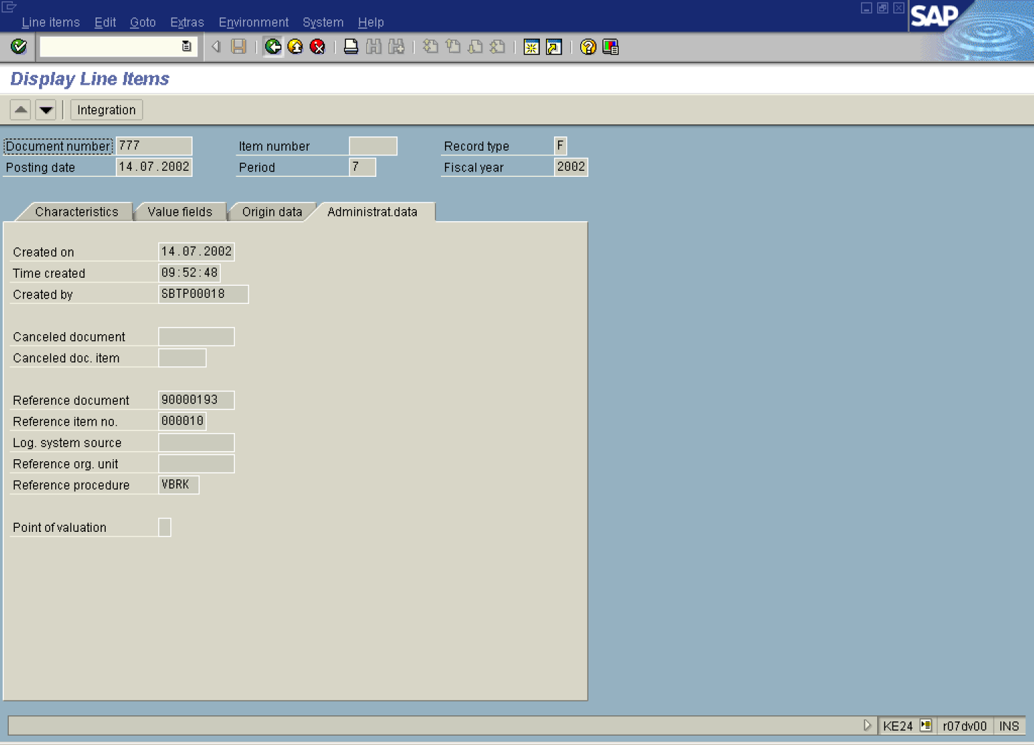

22. Click Back .

Display Actual Line Items: List

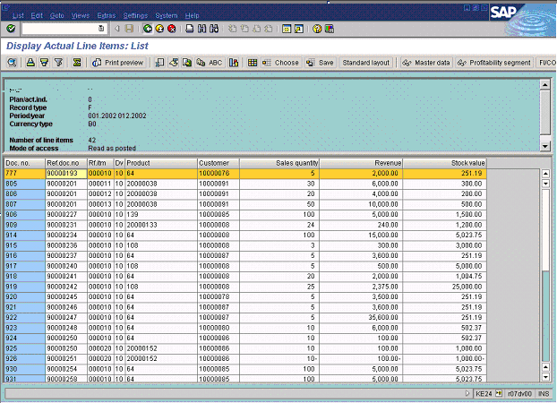

23. Click Back .

